**OUTREACH SCHOOLS EXAMINATION BOARD**

 **END OF TERM II EXAMINATION 2024**

**BABY CLASS: (3 – 4 YEARS)**

**LEARNING AREA 3: HEALTH HABITS**

**My name is: …………………………….…………..………………………….**

**My School is: ………………………….………..………….…………………..**

**I am in: ………………………………..…………………………………………………..**

1. **Trace and shade.**

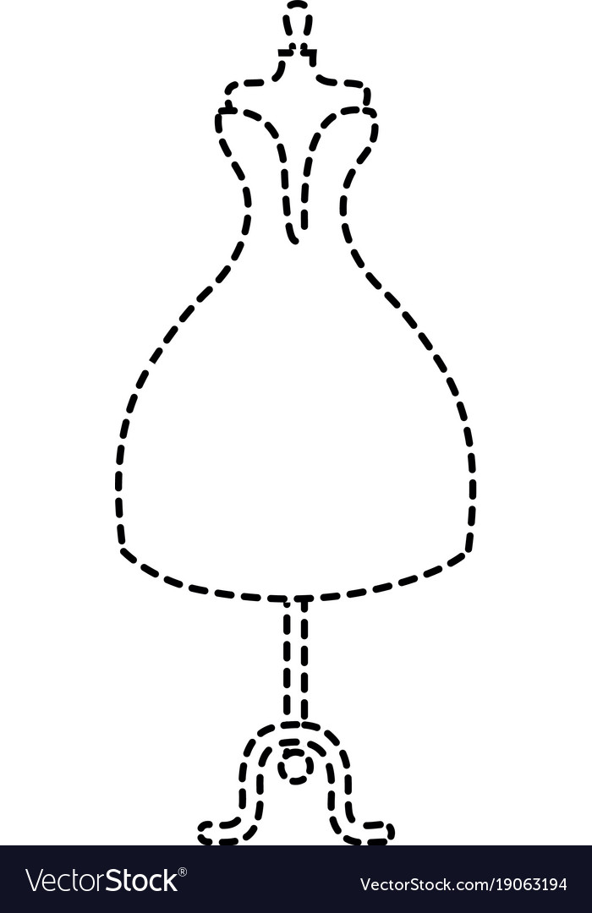

1. **Match the same pictures.**

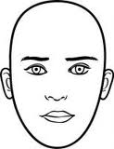



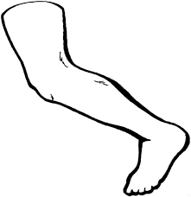

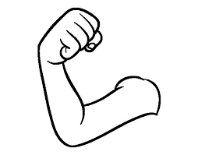



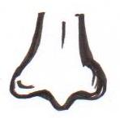







1. **Shade the dangerous objects.**

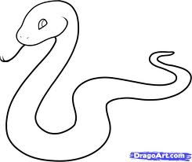

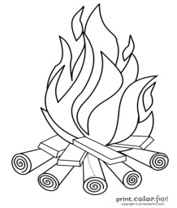

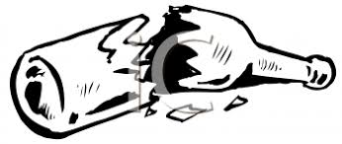

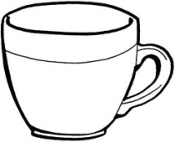

1. **Circle the given picture.**

|  |  |
| --- | --- |
| D:\DESKTOP BACKUP\assesst\SAM PICTURES\SAM PICTURES2\fruits\banana.png | D:\DESKTOP BACKUP\assesst\SAM PICTURES\SAM PICTURES2\foods\beans2.jpg D:\DESKTOP BACKUP\assesst\SAM PICTURES\SAM PICTURES2\fruits\banana.png |
| D:\DESKTOP BACKUP\assesst\SAM PICTURES\SAM PICTURES2\animal products\egg 2.jpg | D:\DESKTOP BACKUP\assesst\SAM PICTURES\SAM PICTURES2\animal products\egg 2.jpg D:\DESKTOP BACKUP\assesst\SAM PICTURES\SAM PICTURES2\fruits\apple 4.png |
| D:\DESKTOP BACKUP\assesst\SAM PICTURES\SAM PICTURES2\animal outlines\fish2.jpg | D:\DESKTOP BACKUP\assesst\SAM PICTURES\SAM PICTURES2\animal outlines\fish2.jpg D:\REBECCA 2012\PUB60COR\FD00428_.WMF |
| D:\DESKTOP BACKUP\assesst\SAM PICTURES\SAM PICTURES2\fruits\apple 4.png | D:\DESKTOP BACKUP\assesst\SAM PICTURES\SAM PICTURES2\foods\beans2.jpg D:\DESKTOP BACKUP\assesst\SAM PICTURES\SAM PICTURES2\fruits\apple 4.png |
| http://t2.gstatic.com/images?q=tbn:ANd9GcQUvpkTFhZzlkimd923nqWo7ZTFyOnBQSrEi97Bg2kSqtV4jT-FDQ | D:\DESKTOP BACKUP\assesst\SAM PICTURES\SAM PICTURES2\foods\beans2.jpghttp://t2.gstatic.com/images?q=tbn:ANd9GcQUvpkTFhZzlkimd923nqWo7ZTFyOnBQSrEi97Bg2kSqtV4jT-FDQ |

**END**